**Objective**: In this lab we will learn more Azure services and data visualization tools.

**Required Setup**: Labs from previous week.

**Parts:**

* PowerBI Desktop
* Tableau Desktop
* Azure account
* A Windows computer

**Part 1: Wrap up and more Azure Services**

For the next two weeks, we are going to complete a more complex project by utilizing the knowledge from previous labs and upcoming new Azure services. So, this week is a perfect week for wrapping up. In week 3, we learned about building a SQL database natively on the Raspberry Pi. From week 4 to week 6, we successfully connected our Raspberry Pi to Azure IoT hub and achieve streaming sensor data using Stream Analytics in real-time. After that, we visualized the data using Microsoft Power BI and be able to reconstruct our database from week 3 with Azure SQL database. The following chart shows full life cycle of the device-cloud interaction.

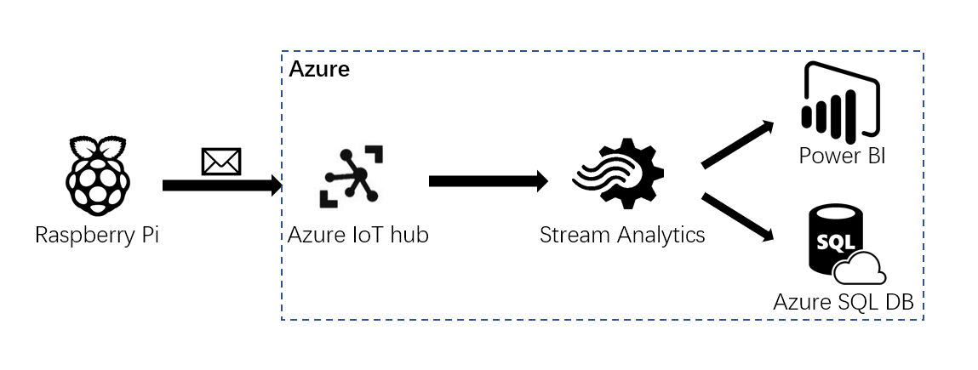

Nowadays, machine learning and AI are the hot topics. Of course, Azure has services related to these topics too. What we are about to learn is one of the usages of AI and it’s called Cognitive Services----Computer Vision. The chart below is a High-level interpretation of what we will do in the next two weeks. Next week, we will do a hands-on lab to learn how to use this specific service. In week 9, we will extend the project to store the result into Azure SQL database and do some analysis using external API. Then we are going to present it by using another web service called Azure Web Apps. You can learn more about the Computer Vision from this [link](https://azure.microsoft.com/en-us/services/cognitive-services/computer-vision/).

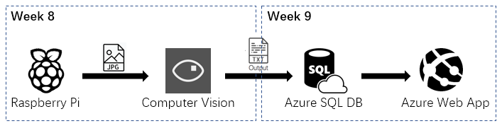

**Part 2: Data Visualization**

In the week 5, we’ve already used Microsoft PowerBI to visualize our temperature data sent from the DHT sensor on our Raspberry Pi. If you search for data visualization tool, PowerBI and Tableau are the two front-runners in the industry. They are very similar and there are millions of articles about the comparison of PowerBI and Tableau on the internet. Feel free to google the topic using the browser. However, in this lab, we will be using the temperature, humidity and sound data in Azure SQL database from the previous lab and visualize them by using both tools. There is no better way to understand a tool than a hands-on experiment. First, if you didn’t do the Bonus part from last week, you will find a python script called ‘week6Answer.py’ in the folder. Modify the ‘Azure IoT hub connection’ in the script. The query used in the Stream Analytics job should be the following.

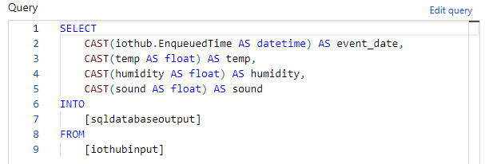

Before continuing with this lab, make sure you have a complete database in your SQL database like the one below.

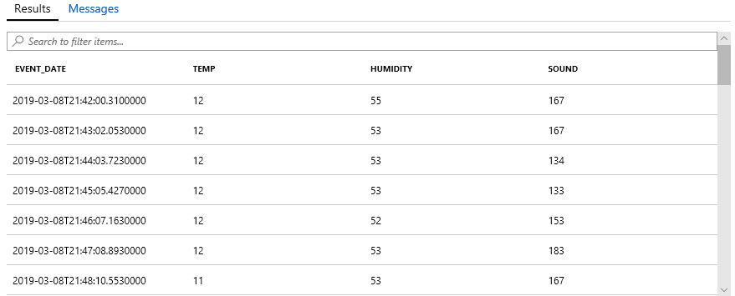

**Step 1.** Open a new tab in the browser and use Google to search ‘Power BI’. Click on the first link and click ‘sign in’ at the top right corner. Use the same login credential of Azure to log in. You should see the following screen.

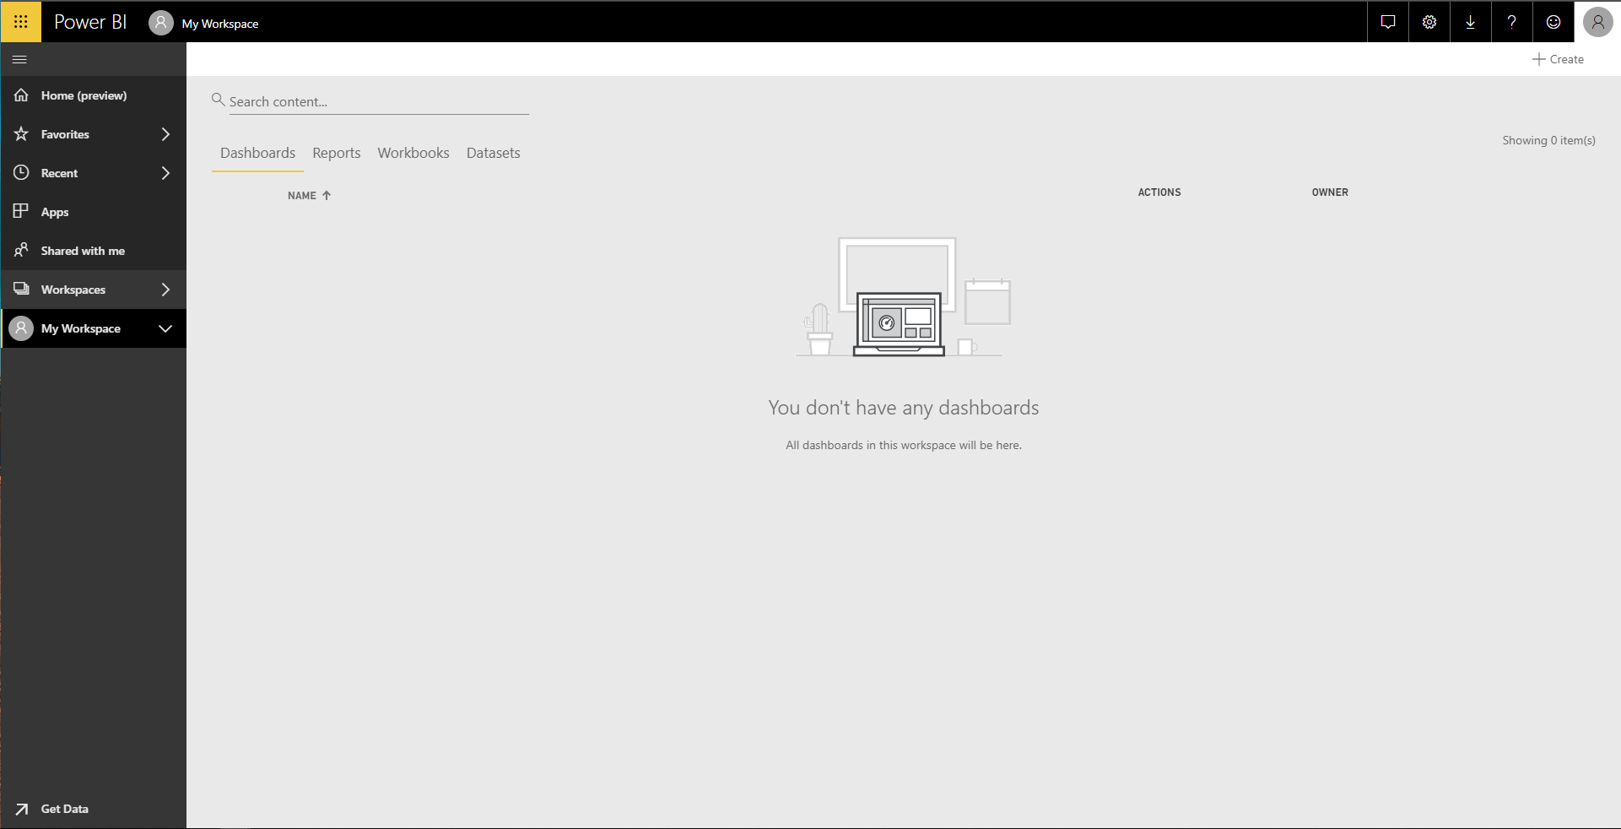

**Step 2.** Click on the ‘Get Data’ at the bottom of the navigation pane. You should get this page.

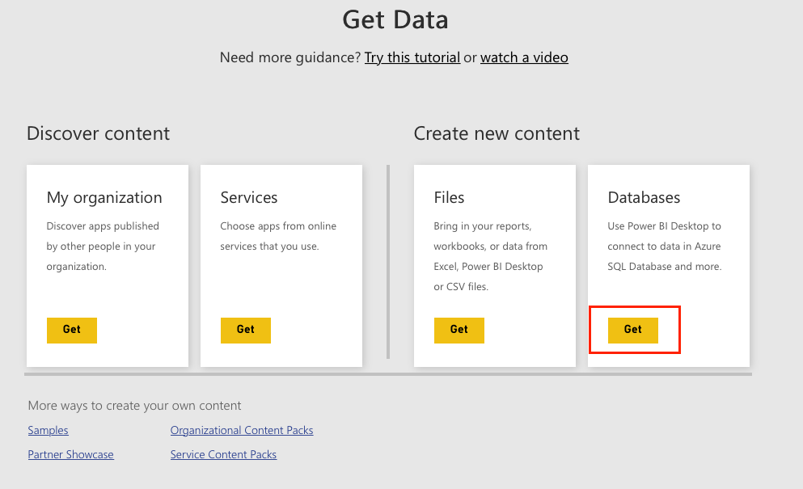

**Step 3.** Click on the ‘Get’ highlighted in the image above to create a new content from Databases. Then choose ‘Azure SQL database’.

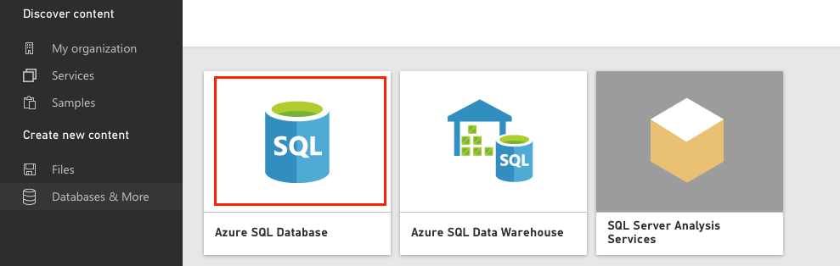

**Step 4.** Click on ‘Download Desktop’. After installation, use your existing account to login. Click on ’Get data’ from the left menu. (Unfortunately, Power BI desktop is only available on Windows.)

**Step 5.** Choose ‘Azure’ from the category on the left, then pick ‘Azure SQL database’. Click ‘connect’.

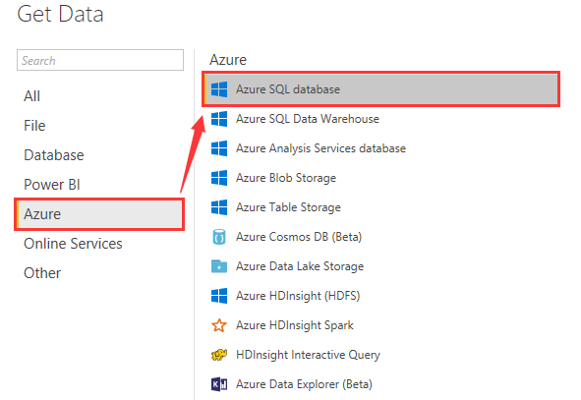

**Step 6.** The following window will prompt. Your Server is {your server name}.database.windows.net. Database name will be the one you created in the **Step** 3. Then click ‘OK’.

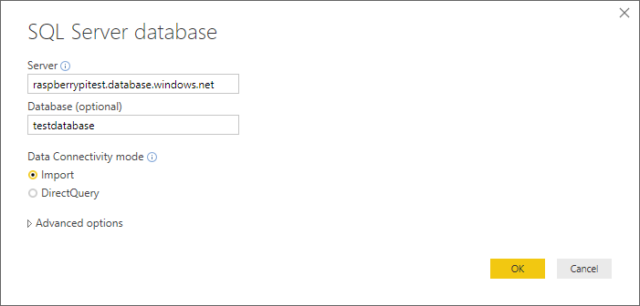

**Step 7.** Choose ‘Temp_Hum_Sound’ from the list on the left. The table will show up on the right. Click ‘Load’.

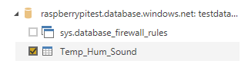

**Step 8.** Pick ‘Line chart’ from the visualization methods.

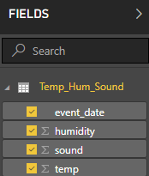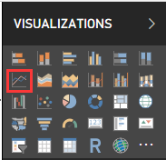

**Step 9.** In the ‘Fields’, check ‘event_date’, ‘humidity’, ‘sound’, and ‘temp.’ You may notice that it automatically sets the ‘event_date’ as x value.

**Step 10.** Click on the down arrow next to the ‘event_date’. Then choose ‘event_date’ in the prompted menu.

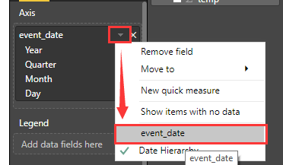

**Step 11.** You should see the similar following line chart. (Your chart will be different based on the sensor data)

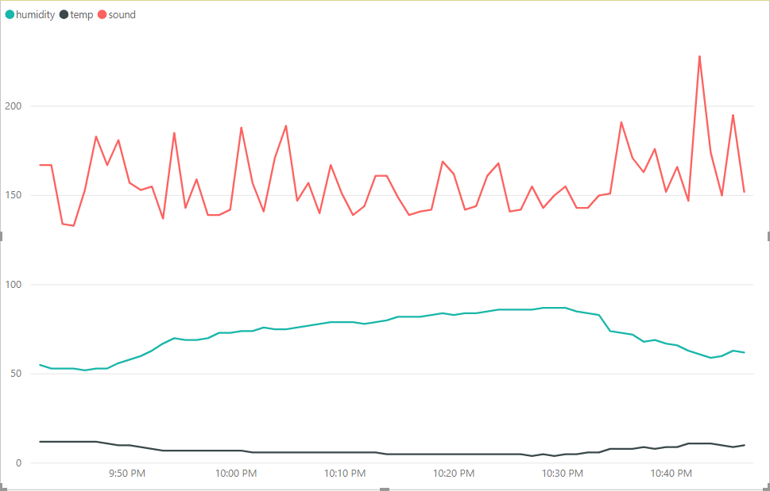

**Step 12.** Feel free to explore other options of tools yourself.

**Now let’s switch to Tableau.**

**Step 1.** Open a new tab and go to <https://www.tableau.com/>. Follow the process to create a new account.

**Step 2.** After creating a new account, click on the orange button ‘Try now’. 

**Step 3.** Next, click on ‘Get Started’ for Tableau Online. The online version has most of the features from the desktop. Tableau is moving everything to the cloud. Guess who’s the service provider? Amazon web service.

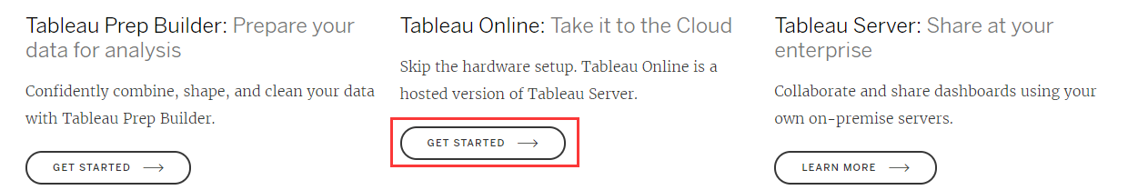

**Step 4.** Click ‘Start your free trail’. Then ‘Sign in to your account’.

**Step 5.** Choose ‘Connect to data’ in the prompted window.

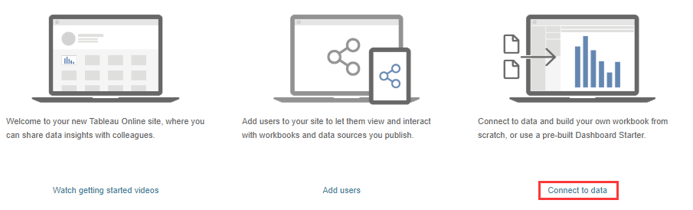

**Step 6.** Switch to Connectors in the menu. Then choose ‘Microsoft SQL Server’

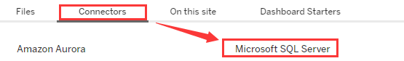

**Step 7.** Put in your login credentials of your Azure SQL database from the previous lab. Click ‘Sign in’.

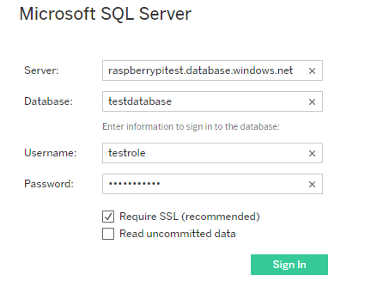

**Step 8.** You will get an error message like the one below. Copy the IP address in the red block.

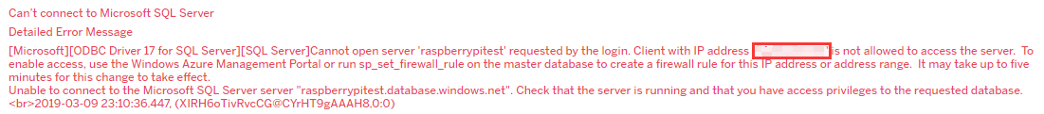

**Step 9.** Login your azure sql database. Make sure you are on ‘Overview’ page.

**Step 10.** Click on ‘Set server firewall’ from the top menu.



**Step 11.** Paste the IP address you just copied from the error message to ‘START IP’ and ‘END IP’. Then choose any ‘RULE NAME’ but it has to be unique. Click ‘Save’ at the top left corner.

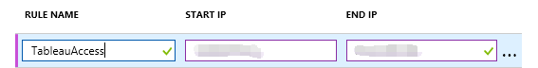

**Step 12.** Go back to the login page of our Connector. Put in your credentials and now you should be able to sign in.

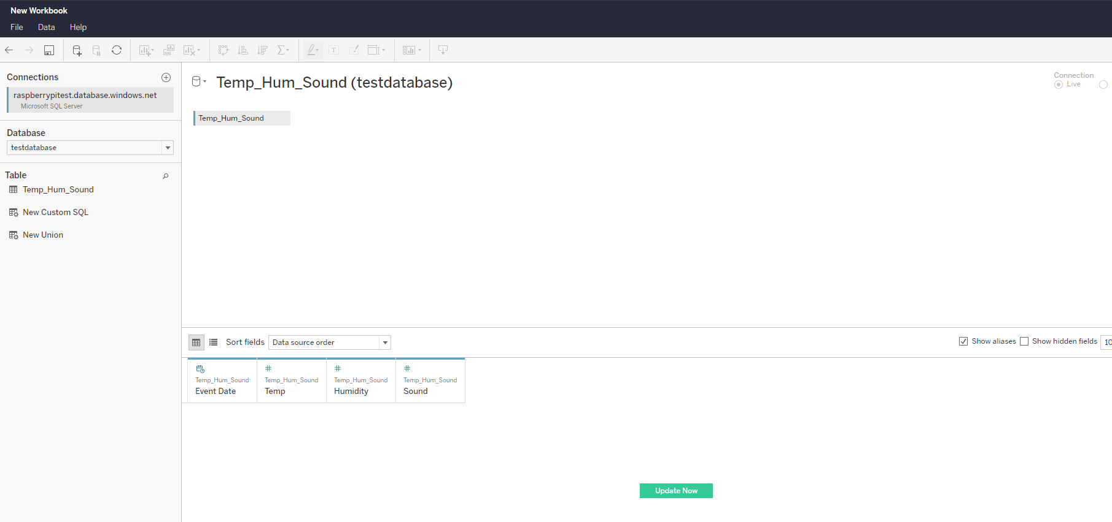

**Step 13.** Now we successfully connected to the data source. Click on the ‘Sheet 1’ on the bottom navigation bar.



**Step 14.** From the left ‘date list’, click and hold ‘Event Date’ from ‘Dimensions’, drag and release it in the ‘Columns’

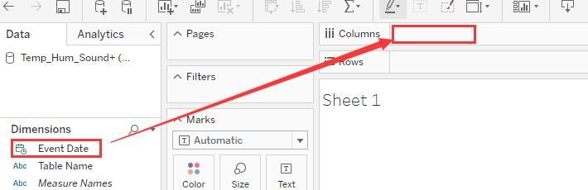

**Step 15.** From the left ‘date list’, click and hold ‘Humidity’, ‘Sound’, and ‘Temo’ from ‘Dimensions’, drag and release them in the ‘Rows’.

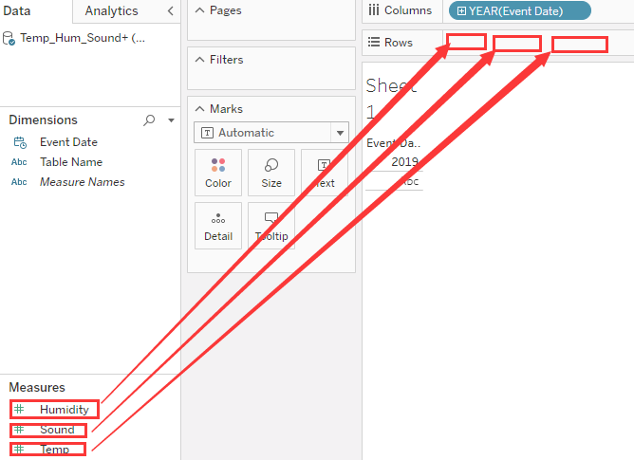

**Step 16.** Hover your mouse cursor on the ‘SUM(Humidity)’ in ‘Rows’. Click on the little triangle to open setting. Choose ‘Dimension’. Do the same thing to ‘SUM(Sound)’ and ‘SUM(Temp)’.

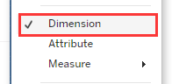

**Step 17.** Hover your cursor on the ‘YEAR(Event Date)’ and open setting. Click on ‘Exact Date’. We are simply just tweaking the settings on those attributes.

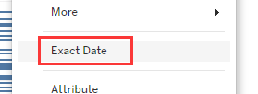

**Step 18.** Now you should see a similar chart like following.

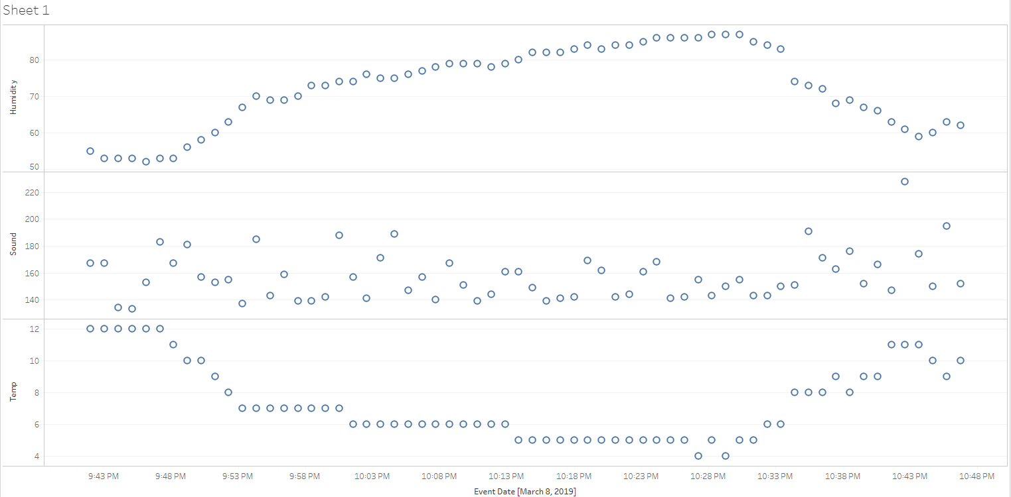

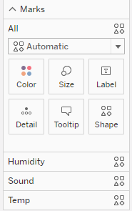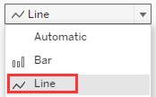**Step 19.** Let’s try to make these three charts into a same chart. In the left menu of the sheet, you can customize the marks for each charts. Expand the drop down menu for All. Click on ‘Line’ and you will see that the dots turn to lines on the charts. Now click on ‘Color’ , you can pick different colors for different attributes.

Play around with it and try to choose three different colors for ‘Humidity’, ‘Sound’, and ‘Temp’. Then merge them into one chart.

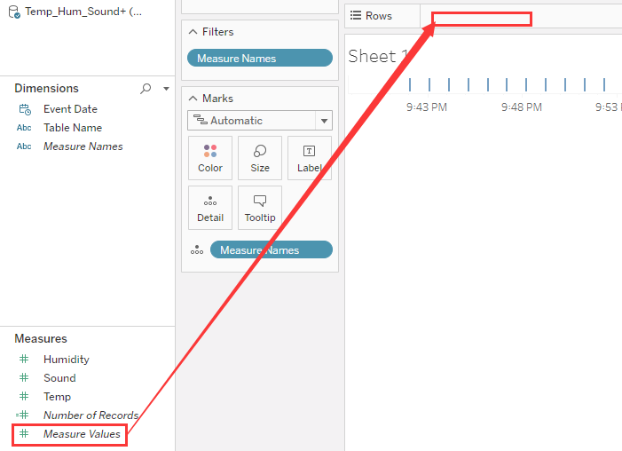**Step 20.** It’s ok if you can’t merge three charts into one because it’s a bit tricky. Open ‘setting’ for all the attributes on the ‘Rows’ and click on ‘Remove’ to delete them. Now there is another attribute called ‘Measure Values’ in ‘Measures’. Drag ‘Measure Values’ to ‘Rows’.

**Step 21.** Remove ‘SUM(Number of Records)’. Now you should get a chart which exactly like the one we got in Power BI and they should because we are using the same database.

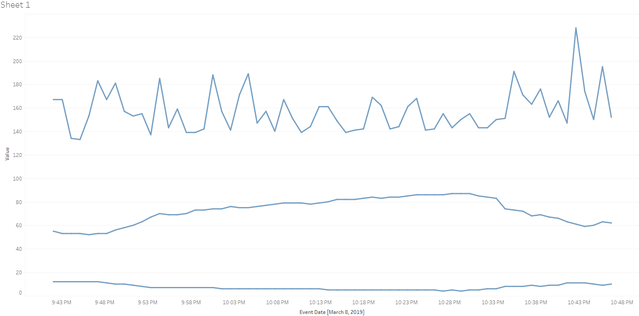

**Step 22.** Explore more options on your own and this is the end of the lab. What do you think? Which one do you prefer to use? Share your idea with others.

Reference:

1. <https://powerbi.microsoft.com/en-us/blog/using-power-bi-to-visualize-and-explore-azure-sql-databases/>